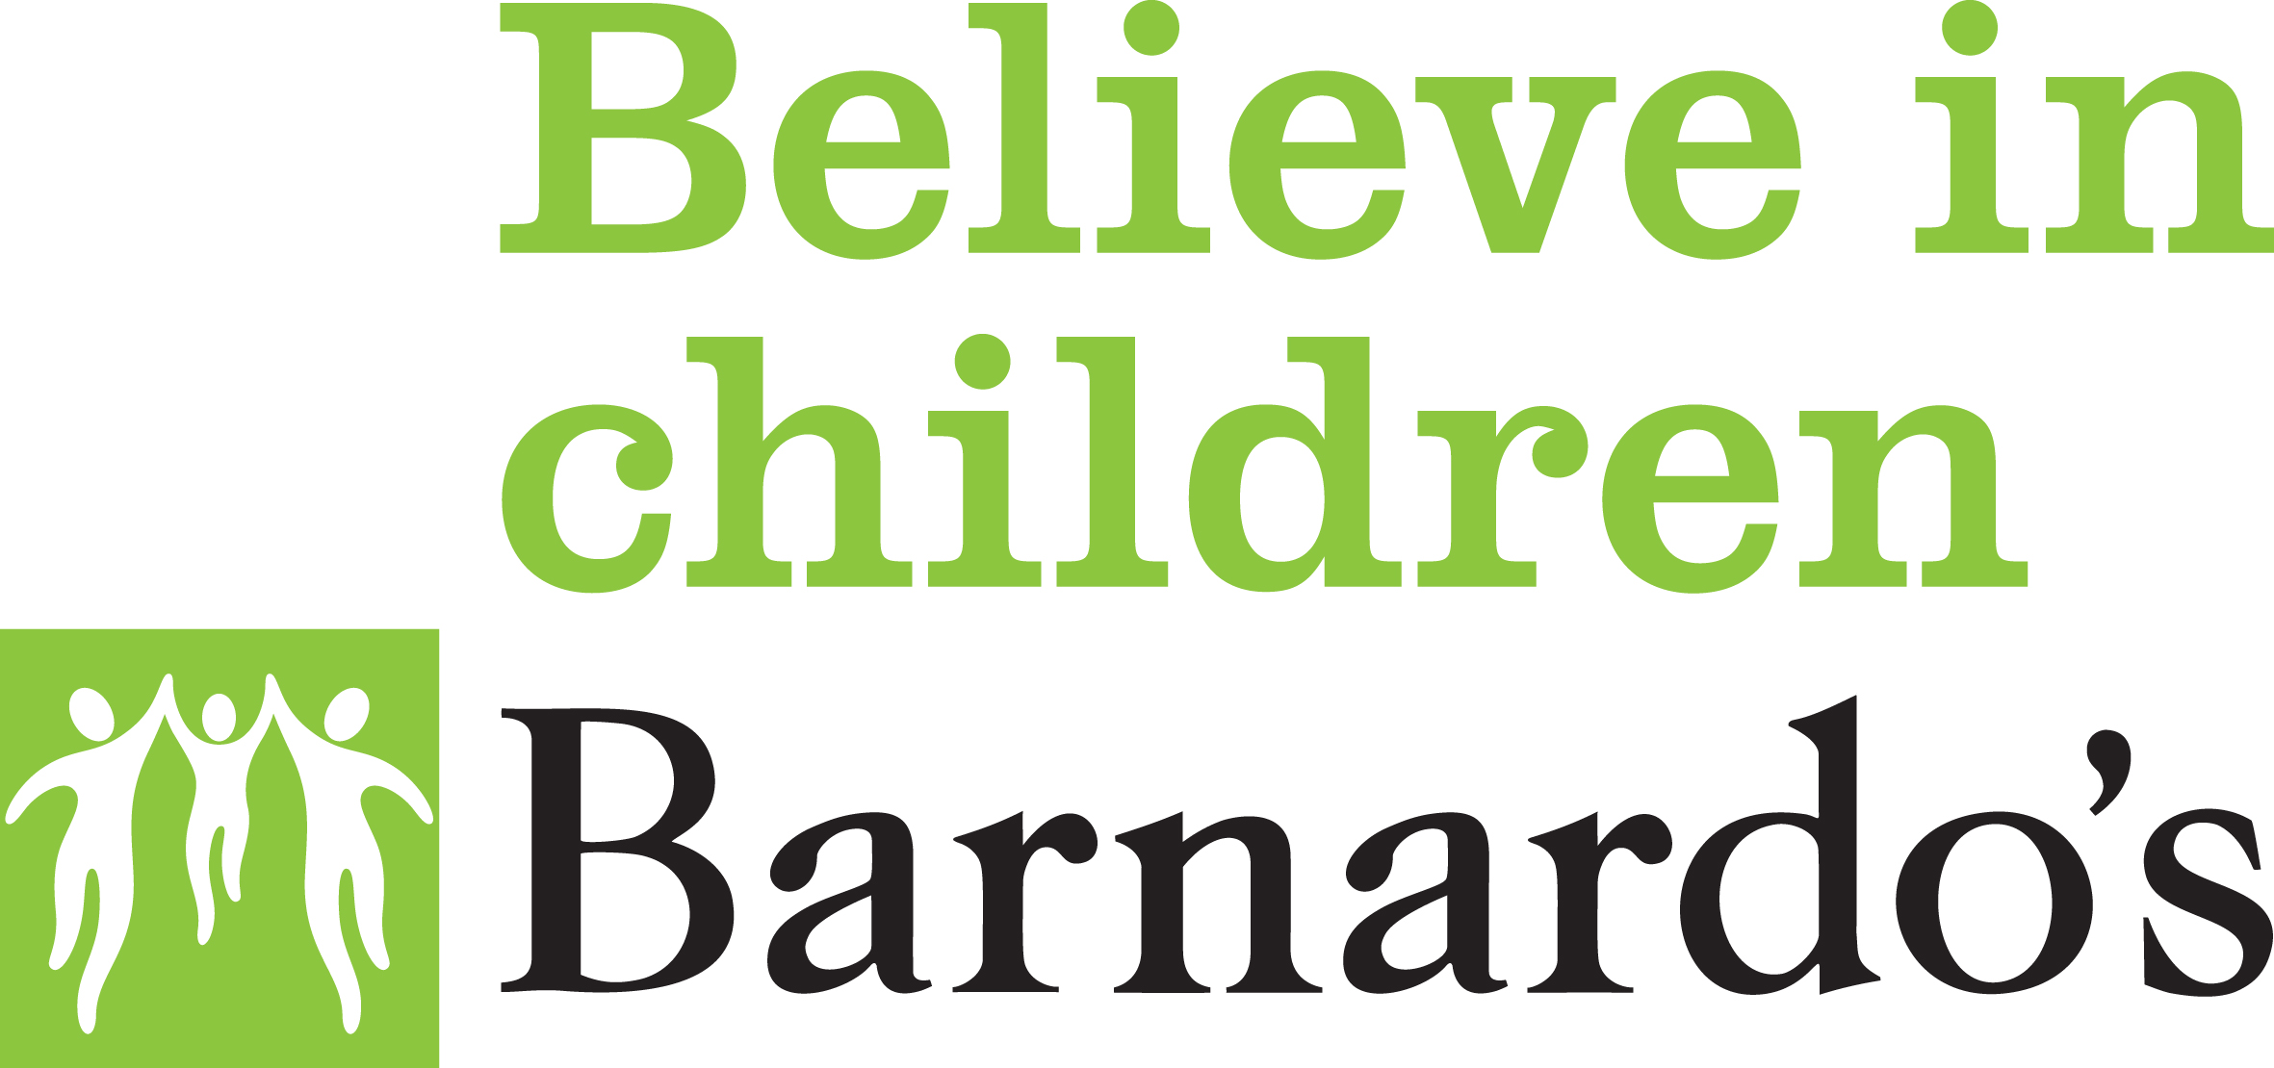

Retail Store Safeguarding Risk Assessment

STORE: REGION/AREA: STORE MANAGER:

- This Safeguarding Risk Assessment must be undertaken by the Store Manager in the first instance and then every 6 months, this is in relation to all the stores staff and volunteers.
- This document should be completed by circling the appropriate response and providing further detail where requested.
- Any concerns should be raised with the Area Business Manager.
- Once completed, this form should be passed to the Area Business Manager for review.
- Further advice can be sought from the Income and Innovation People Team.

Area | Response
- Do you have any young people working/volunteering in the store who are under 18 years of age? | YES / NO (please circle)  If yes, please list and in addition confirm how often are young people working or volunteering in the store?  ________________________________________________________________________________________________________________________________________________________________________________________________________________________________________________________________________
- Is there anyone working/volunteering in the store with additional support needs (who may be considered vulnerable) or who require reasonable adjustments to enable them to carry out their role effectively?  Supervision and review form completed and on file.  Supervision and Review form | YES / NO  If yes, please state the individual, their role and the support/ adjustment required?  ____________________________________________________________________________________________________________________________________________________________________________________________________________________________________________________________________________________________________________________________________________________________________________________________________________
- Have any additional support needs/reasonable adjustments been discussed (the accessibility passport Accessibility Passport can be reviewed as required) with the individual(s) and a separate Risk Assessment completed?  Individual Form | If yes, please confirm the details and date of discussion and confirmation of the risk assessment?  ____________________________________________________________________________________________________________________________________________________________________________________________________________________________________________________________________________________________________________________________________________________________________________________________________________
- If required, have these support needs/reasonable adjustments been met? | YES / NO (If no, please give reasons below)  __________________________________________________________________________________________________________________________________________________________________________________________________________________________________________________________________________________________________________________________________________
- Do you consider these to be working well? | YES / NO (If no, please give reasons/ detail below)  __________________________________________________________________________________________________________________________________________________________________________________________________________________________________________________________________________________________________________________________________________
- How often do reviews take place of the support/reasonable adjustments implemented? | Please specify the review date if these are before the six monthly risk assessment review. ____________________________________________________________________________________________________________________________________  Please circle: Never/ Every quarter/Every six months/Annually
- Do staff/volunteers work on their own within the store? | YES / NO  If yes, please confirm the details?  ____________________________________________________________________________________________________________________________________________________________________________________
- Does regular supervision take place of employed staff?  (definition of supervision is that team members are regularly communicated with about their work, this does not need to be a formal meeting, a casual conversation over a coffee or just general chat about work can also qualify) | YES / NO
- Have all volunteers/staff working in the store signed up to Barnardo’s safeguarding code of conduct and is a copy held for volunteers in their individual file? | YES / NO  If No, please confirm the reason and when this will be rectified?  ________________________________________________________________________________________________________________________________________________________________________________________________________________________________________________
- Are all staff/volunteers aware of the professional boundaries policy, Volunteer Code of Conduct and how it relates to their job role? | YES / NO  If No, please confirm the reason and when this will be rectified?  ____________________________________________________________________________________________________________________________________________________________________________________
- Do you have, or have you had any cause for concern regarding an individual’s (staff member or volunteer) professional boundaries? | YES / NO  If yes, please confirm the details?  ____________________________________________________________________________________________________________________________________________________________________________________
- Having undertaken this risk assessment, do you have any areas of concern or any areas that you would like further advice on? | YES / NO  (If yes, please give details or alternatively contact your  Area Business Manager or Income and Innovation People Team)  ____________________________________________________________________________________________________________________________________________________________________________________________________________________________________________________________________________________________________________

- Action taken from point 12:  Date of Action:  Responsible Manager who carried the action: | Other Comments: ____________________________________________________________________________________________________________________________________________________________________________________________________________________________________________________________________________________________________________

Signed: ………………………………. (Store Manager) Date: ………………………..

Signed: ………………………………..(Area Business Manager) Date: ………………………….

