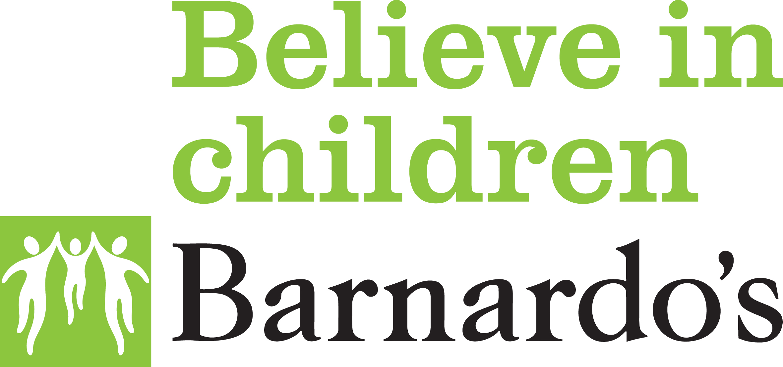

Retail Individual Safeguarding Risk Assessment

NAME: STORE: REGION/AREA:

STORE MANAGER:

- This Individual Safeguarding Risk Assessment must be undertaken by the Store Manager if identified in the Retail Store Safeguarding Assessment.
- This document should be completed by circling the appropriate response and providing further detail where requested.
- Any concerns should be raised with the Area Business Manager.
- Once completed, this form should be passed to the Area Business Manager for review.
- Further advice can be sought from the Income and Innovation People Team.

Area | Response
- What is the identified risk?

Examples;

Sexual, physical, emotional, verbal, neglect, inappropriate behaviour, financial abuse, substance abuse.
- Who is the risk to?

Example;
Children, vulnerable adults, customers, staff within the store, volunteers, everyone, named person(s)

- When is the risk behaviour likely to occur?

Example;
In store, on route to the store, in the community, during a particular task, other – specify OR

This is very unlikely to occur as is mentioned as an acknowledgement of the historic conviction

- Protective measures in place?  Example;  Notification to ABM and higher management  Notification to Safeguarding colleagues – safeguarding escalation process activated  Adjustments to work practices to limit risk  Accessibility passport used  Team members in store are safe via supervision | YES / NO  If No, please confirm the reason and when this will be rectified?
Date of Action:  Responsible Manager who carried the action: | Other Comments:

Signed: …………………………… (Store Manager) Date: ………………………..

Signed………………………………..(Area Business Manager) Date:………………………….

Please retain a copy for your store file and please send a copy to the Income and Innovation People team.

